How to Create an Account
To create your PowerSchool Parent Portal account, please go to: https://powerschool.eips.ca/public/home.html. And then click on:
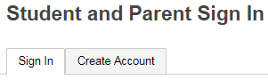

Then complete the highlighted areas. Access ID and Passwords are available from the Westboro Office. If you have any trouble or questions about setting up your account, please contact us at the school.
To Add a Child to Your Account: Click on Account Preferences (left side of screen) and then click on the tab labelled STUDENTS

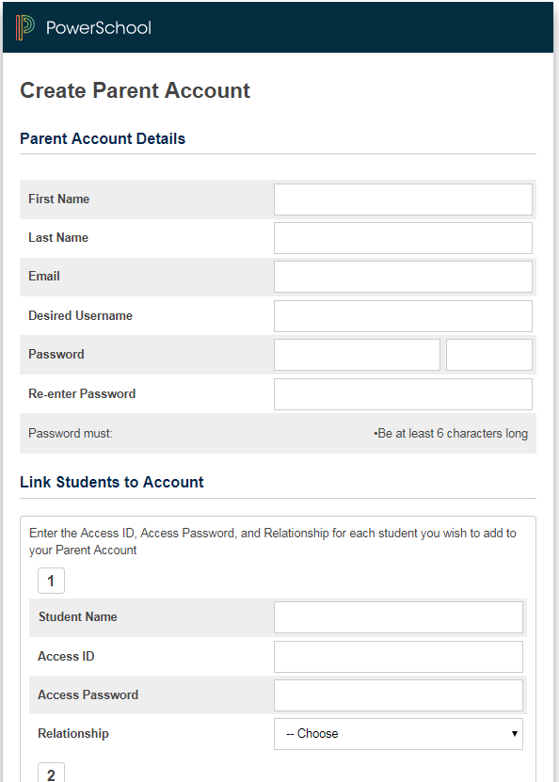
Enter Parent Access ID
Enter Parent Access Password

